**Contents**

1. Security Trends
   * Authentication
   * Authorization
   * Encryption
   * Cybersecurity Current Trends
   * Access Control and Accounting
2. Kubernetes
   * Introduction to Kubernetes
   * Creation of Minikube Cluster
   * Performing Basic Commands
3. eBPF Technologies
   * Introduction to eBPF
   * Falcon
   * Tracee
   * Tetragon
   * StackRox
   * Advantages of Tetragon
   * Why We Use Tetragon
4. Execution of Policies Using Tetragon
   * Deploy on a Cluster
   * Defining Security Policies
   * Example Policy: Sudo Invocation Monitoring
   * Policy Management
5. Integration of Grafana with Tetragon
   * Overview of Grafana
   * Integrating Grafana with Tetragon
   * Example Dashboard

**1. Security Trends**

**1.1. Authentication**

Authentication is the process of verifying the identity of a user, device, or system. Modern authentication methods go beyond simple passwords to include multifactor authentication (MFA), biometrics, and federated identity systems. These methods enhance security by making it harder for attackers to gain unauthorized access.

* **Multifactor Authentication (MFA)**: MFA requires users to provide two or more verification factors to gain access. These factors can include something the user knows (password), something the user has (security token), and something the user is (biometric verification).
* **Biometric Authentication**: Biometric systems use unique physical characteristics such as fingerprints, facial recognition, and iris scans. These methods are highly secure as they are difficult to replicate or steal.
* **Federated Identity**: Federated identity management allows users to use a single set of credentials across multiple systems. Services like SAML, OAuth, and OpenID Connect facilitate this by enabling trust relationships between different identity providers and service providers.

**1.2. Authorization**

Authorization determines what resources a user can access and what actions they can perform. Modern authorization strategies include role-based access control (RBAC), attribute-based access control (ABAC), and policy-based access control (PBAC).

* **Role-Based Access Control (RBAC)**: RBAC assigns permissions to users based on their roles within an organization. This simplifies management and ensures that users have access only to what they need to perform their job functions.
* **Attribute-Based Access Control (ABAC)**: ABAC considers multiple attributes (user role, department, time of day, etc.) to determine access rights. This provides a more granular and flexible approach to access control compared to RBAC.
* **Policy-Based Access Control (PBAC)**: PBAC uses predefined policies to control access. Policies are typically written in a language that specifies conditions under which access is granted or denied.

**1.3. Encryption**

Encryption is a critical component of modern security, protecting data both in transit and at rest. Encryption algorithms convert plaintext data into ciphertext, which can only be deciphered by someone with the correct decryption key.

* **Symmetric Encryption**: In symmetric encryption, the same key is used for both encryption and decryption. Common algorithms include AES (Advanced Encryption Standard) and DES (Data Encryption Standard).
* **Asymmetric Encryption**: Asymmetric encryption uses a pair of keys – a public key for encryption and a private key for decryption. RSA (Rivest-Shamir-Adleman) and ECC (Elliptic Curve Cryptography) are popular asymmetric encryption algorithms.
* **End-to-End Encryption (E2EE)**: E2EE ensures that data is encrypted on the sender's side and only decrypted on the recipient's side, preventing intermediaries from accessing the data. This is commonly used in messaging apps and secure communication channels.

**1.4. Cybersecurity Current Trends**

The field of cybersecurity is constantly evolving to address new threats and challenges. Key trends in 2024 include:

* **Zero Trust Security**: Zero Trust is a security model that assumes no implicit trust and verifies every request as if it originates from an open network. Core principles include continuous verification, least privilege, and micro segmentation.
* **Extended Detection and Response (XDR)**: XDR integrates multiple security products into a cohesive system that provides a holistic view of threats across an organization. It enhances threat detection and response through comprehensive visibility, advanced threat detection, and automated response.
* **Cloud Security**: With the increasing adoption of cloud services, securing cloud environments has become critical. Key aspects of cloud security include Cloud Security Posture Management (CSPM), Cloud Workload Protection Platforms (CWPP), and Secure Access to Cloud Services (SACS).
* **IoT Security**: The proliferation of IoT devices introduces new security challenges, as these devices can be entry points for attackers. Key IoT security measures include device authentication and authorization, firmware updates and patching, and network segmentation.
* **Artificial Intelligence in Security**: AI and machine learning are transforming security by enabling more effective threat detection, incident response, and predictive analytics. AI identifies patterns and anomalies, automates response actions, and predicts future threats based on historical data and trends.

**1.5. Access Control and Accounting**

Access control is the selective restriction of access to data, resources, or systems. Modern access control strategies include:

* **Identity and Access Management (IAM)**: IAM solutions manage digital identities and control access to resources. They include functionalities like single sign-on (SSO), multi-factor authentication (MFA), and role-based access control (RBAC).
* **Network Access Control (NAC)**: NAC solutions enforce security policies on devices accessing the network, ensuring that only compliant devices are allowed to connect.
* **Physical Access Control**: This includes mechanisms like biometric scanners, keycards, and security guards to control physical access to facilities and sensitive areas.
* **Accounting (Audit Logs)**: Accounting involves maintaining logs of user activities and access events. Audit logs are crucial for detecting and investigating security incidents, ensuring compliance, and providing forensic evidence in the event of a breach.
* **Logging and Monitoring**: Continuous logging and monitoring of user activities, system events, and network traffic help detect anomalies and potential security breaches in real time.

---

## 2. Kubernetes

### 2.1. Introduction to Kubernetes

Kubernetes is an open-source container orchestration platform that automates the deployment, scaling, and management of containerized applications. Developed by Google, Kubernetes has become the de facto standard for container orchestration due to its robust feature set, including:

* **Automated Rollouts and Rollbacks**: Kubernetes manages application updates and can roll back changes if something goes wrong.
* **Self-Healing**: Kubernetes automatically replaces failed containers, ensuring that applications remain available.
* **Horizontal Scaling**: Kubernetes scales applications automatically based on resource usage and demand.
* **Service Discovery and Load Balancing**: Kubernetes distributes traffic across containers and provides internal DNS for service discovery.

### 2.2. Creation of Minikube Cluster

Minikube is a tool that allows you to run Kubernetes locally. It provides a simple way to create a single-node Kubernetes cluster on your local machine, making it ideal for development and testing.

#### Steps to Create Minikube

1. **Install Minikube**:

curl -LO https://storage.googleapis.com/minikube/releases/latest/minikube-linux-amd64

sudo install minikube-linux-amd64 /usr/local/bin/minikube

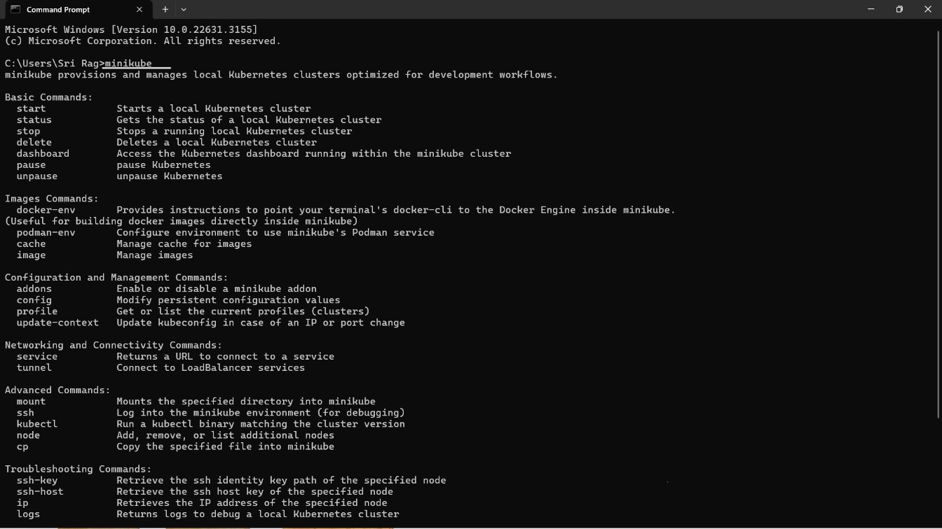

1. **Start Minikube**:

minikube start

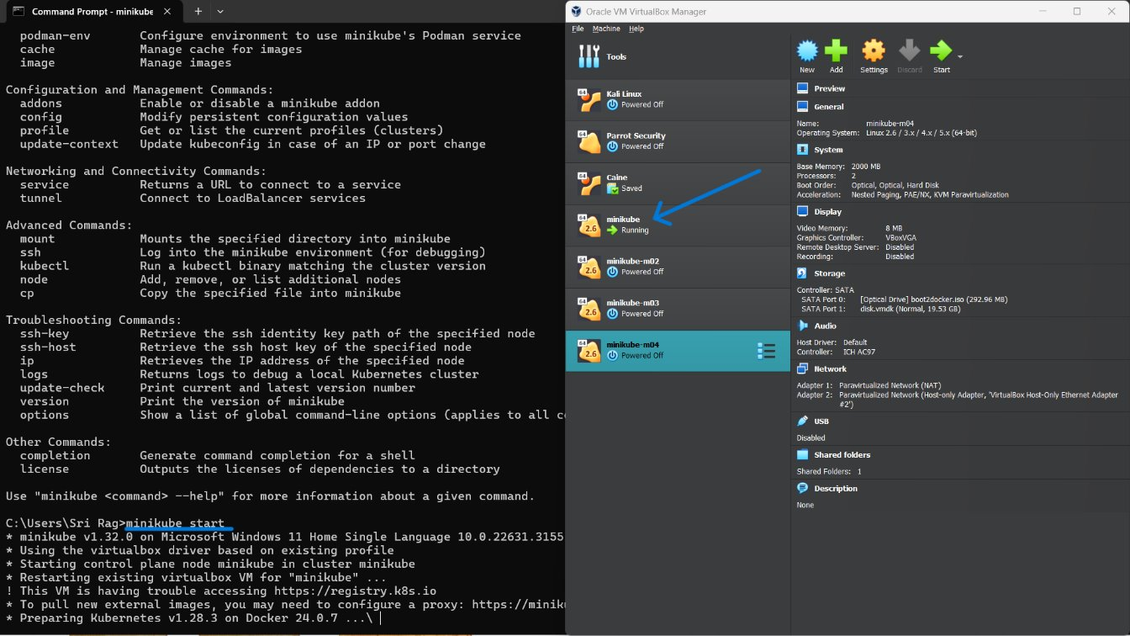

1. **Verify Minikube Installation**:

kubectl get nodes

Minikube creates a local Kubernetes cluster with a single node, allowing you to experiment with Kubernetes features and run containerized applications.

### 2.3. Performing Basic Commands

Once Minikube is set up, you can use Kubernetes commands to manage your cluster. Here are some basic commands to get you started:

### Deploy an app and view the app

### A screenshot of a computer Description automatically generatedA screenshot of a computer Description automatically generatedThe command `kubectl create deployment kubernetes-bootcamp --image=gcr.io/google-samples/kubernetes-bootcamp:v1` deploys an application on Kubernetes. This creates a deployment which instructs Kubernetes to run your app encapsulated in a container. To view the application, you can use `kubectl proxy` to establish a connection with the cluster's internal network and then access the pod's API endpoint.

### **Explore Your App**

### To view the application's output in the terminal, run `kubectl proxy` in a separate terminal. This creates a proxy for the cluster's internal network. Then, get the pod name using `kubectl get pods -o go-template ...` and use it to construct a URL for the pod's API endpoint. Finally, use `curl` with that URL to see the application's output.

### A screenshot of a computer program Description automatically generatedLoad Balancing A blue screen with white text Description automatically generatedA blue screen with white text Description automatically generatedA screen shot of a computer Description automatically generated

### A computer screen shot of a blue screen Description automatically generatedA screenshot of a computer Description automatically generatedScale Down

### **UPDATE YOUR APP-ROLLING UPDATES**

**Old version**

By performing these basic commands, you can gain hands-on experience with Kubernetes and understand how it manages containerized applications.

## 3. eBPF Technologies

### 3.1. Introduction to eBPF

eBPF (extended Berkeley Packet Filter) is a powerful technology that allows programs to run within the Linux kernel, providing capabilities for network monitoring, performance profiling, and security enforcement. eBPF programs are loaded into the kernel and attached to various events such as system calls, network packets, and tracepoints.

### 3.2. Falcon

Falcon is an eBPF-based security platform designed for real-time visibility and threat detection. It monitors system activities and network traffic, providing deep insights into system behavior. Key features include:

* **Real-Time Monitoring**: Falcon leverages eBPF to capture and analyze system events in real time, enabling immediate detection of suspicious activities.
* **Threat Detection**: Using predefined rules and machine learning models, Falcon identifies potential threats and generates alerts for security teams.
* **Forensic Analysis**: Falcon provides detailed logs and traces of system activities, aiding in forensic investigations and incident response.

### 3.3. Tracee

Tracee is an open-source runtime security and forensics tool that uses eBPF to trace system calls and other events. It is designed to detect anomalies and provide detailed insights into system behavior.

* **Anomaly Detection**: Tracee identifies anomalies by monitoring system calls and comparing them against known patterns of malicious behavior.
* **Detailed Tracing**: Tracee provides detailed traces of system events, including arguments and return values of system calls, aiding in root cause analysis.
* **Extensibility**: Tracee allows users to define custom detection rules and extend its capabilities to suit specific security needs.

### 3.4. Tetragon

Tetragon is an eBPF-based platform for runtime security and observability. It offers deep visibility into system activities and enforces security policies based on real-time observations.

* **Deep Observability**: Tetragon monitors system calls, network activities, and other kernel events, providing comprehensive insights into system behavior.
* **Security Enforcement**: Tetragon enforces security policies dynamically, based on real-time observations, preventing malicious activities before they can impact the system.
* **Performance Efficiency**: Tetragon's use of eBPF ensures minimal performance overhead, making it suitable for production environments.

### 3.5. StackRox

StackRox is a security platform for Kubernetes that leverages eBPF to provide deep visibility and runtime protection for containerized applications. It integrates with Kubernetes to enforce security policies and detect threats.

* **Kubernetes Integration**: StackRox integrates seamlessly with Kubernetes, providing visibility and security controls specific to containerized environments.
* **Runtime Protection**: Using eBPF, StackRox monitors system activities and enforces security policies to protect against runtime threats.
* **Compliance Monitoring**: StackRox helps organizations meet compliance requirements by monitoring and auditing Kubernetes configurations and activities.

### 3.6. Advantages of Tetragon

Tetragon offers several advantages that make it a valuable tool for security and observability:

#### Deep Observability

Tetragon provides unparalleled visibility into system behavior by leveraging eBPF to monitor system calls, network activity, and other kernel events. This deep observability allows for the detection of subtle indicators of compromise and provides detailed insights necessary for thorough forensic analysis.

#### Security Enforcement

Tetragon enables dynamic enforcement of security policies based on real-time system behavior. This capability ensures that security measures are adaptive and responsive to emerging threats, preventing malicious activity before it can impact the system.

#### Performance Efficiency

Tetragon’s use of eBPF ensures that its monitoring and enforcement capabilities have minimal performance overhead. This efficiency is critical for maintaining the performance of production systems while ensuring robust security and observability.

#### Flexibility

Tetragon supports a wide range of use cases, from runtime protection to compliance monitoring. Its flexibility allows it to be integrated into various environments and workflows, making it a versatile tool for security teams.

### 3.7. Why We Use Tetragon

We use Tetragon for several reasons:

1. **Comprehensive Monitoring**: Tetragon’s ability to monitor system calls, network activity, and other kernel events provides comprehensive coverage of potential attack vectors.
2. **Real-Time Response**: The platform’s dynamic enforcement capabilities ensure that security policies can respond to threats in real time, enhancing our security posture.
3. **Minimal Overhead**: Tetragon’s eBPF-based approach ensures that security monitoring and enforcement do not degrade system performance.
4. **Integration Capabilities**: Tetragon integrates well with other tools in our security stack, including observability platforms like Grafana, providing a cohesive and efficient security solution.

## 4. Execution of Policies Using Tetragon

### 4.1. Deploy on a Cluster

### helm repo add cilium https://helm.cilium.io

### helm repo update

### helm install tetragon cilium/tetragon -n kube-system

### To wait until Tetragon deployment is ready, use the following kubectl command:

### kubectl rollout status -n kube-system ds/tetragon -w

### 

### 4.2. Defining Security Policies

Security policies in Tetragon are defined using eBPF programs that are attached to specific system events. These policies can be tailored to enforce various security measures, such as preventing unauthorized executions, blocking network connections, or monitoring file access.

### 4.3. Example Policy: Sudo Invocation Monitoring

### Use Case

sudo is used to run executables with particular privileges. Creating an audit log of sudo invocations is a common best-practice.

No policy needs to be loaded, standard process execution observability is sufficient.

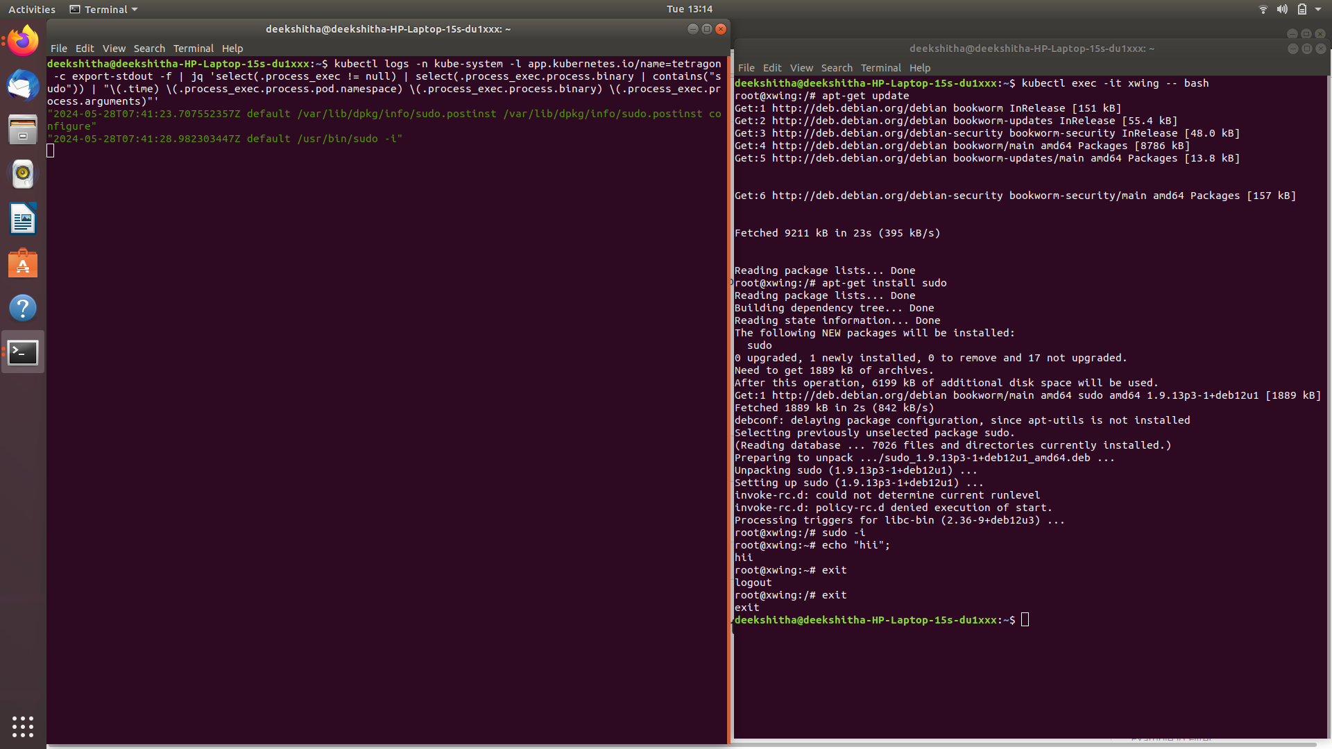

### 4.4. Policy Management

Tetragon provides tools for managing policies, including loading, attaching, and detaching eBPF programs. Policies can be dynamically adjusted based on real-time observations, ensuring that security measures remain effective against evolving threats.

## 5. Integration of Grafana with Tetragon

### 5.1. Overview of Grafana

Grafana is an open-source platform for monitoring and observability. It enables the visualization of metrics, logs, and traces from various data sources, providing a comprehensive view of system health and performance.

### 5.2. Integrating Grafana with Tetragon for metrics

To integrate Grafana with Tetragon, follow these steps:

Enable prometheus metrics as follows:

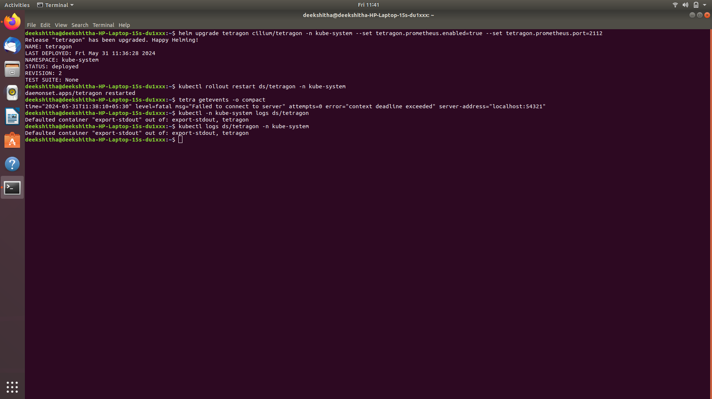

Typically, metrics are scraped by Prometheus or another compatible agent (for example OpenTelemetry Collector), stored in Prometheus or another compatible database, then queried and visualized for example using Grafana.

In Kubernetes, you can install Prometheus and Grafana using the kube-prometheus-stack Helm chart:

helm repo add prometheus-community https://prometheus-community.github.io/helm-charts

helm install kube-prometheus-stack prometheus-community/kube-prometheus-stack \

--namespace monitoring --create-namespace \

--set prometheus.prometheusSpec.serviceMonitorSelectorNilUsesHelmValues=false

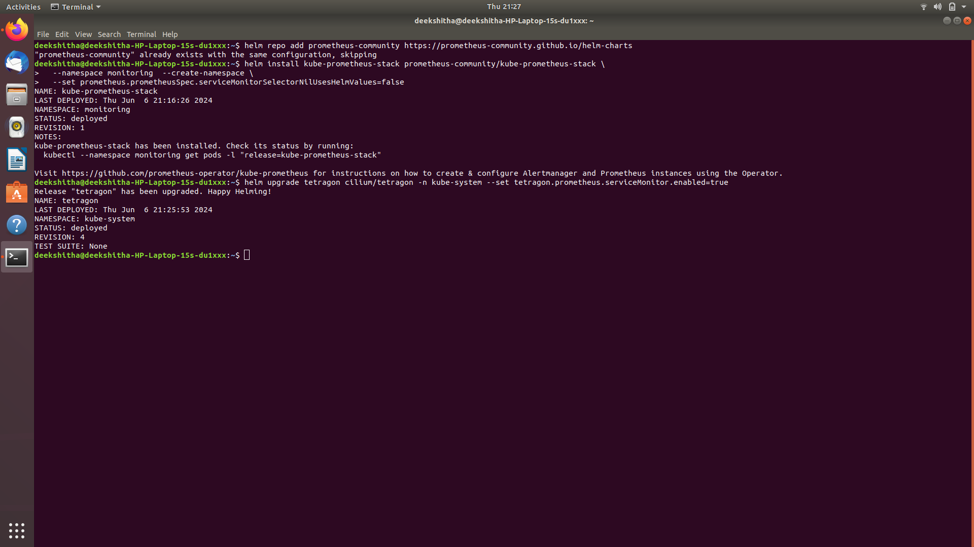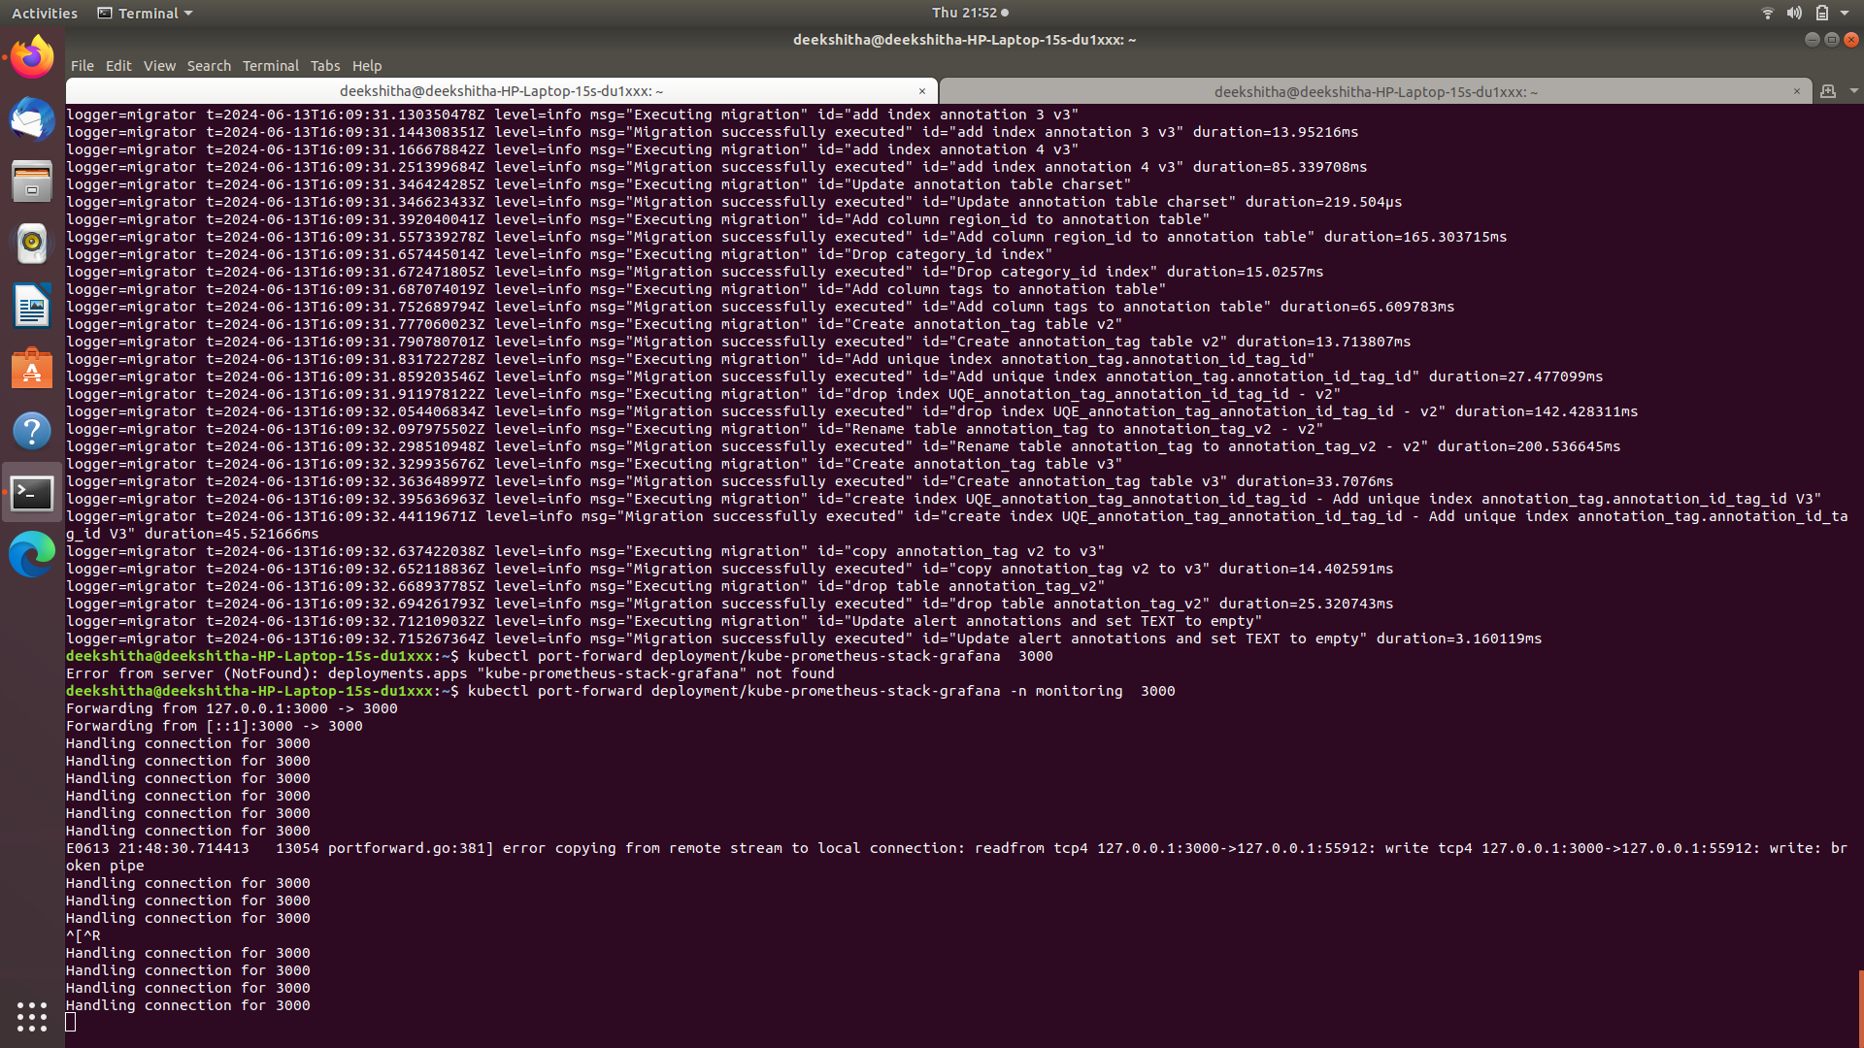

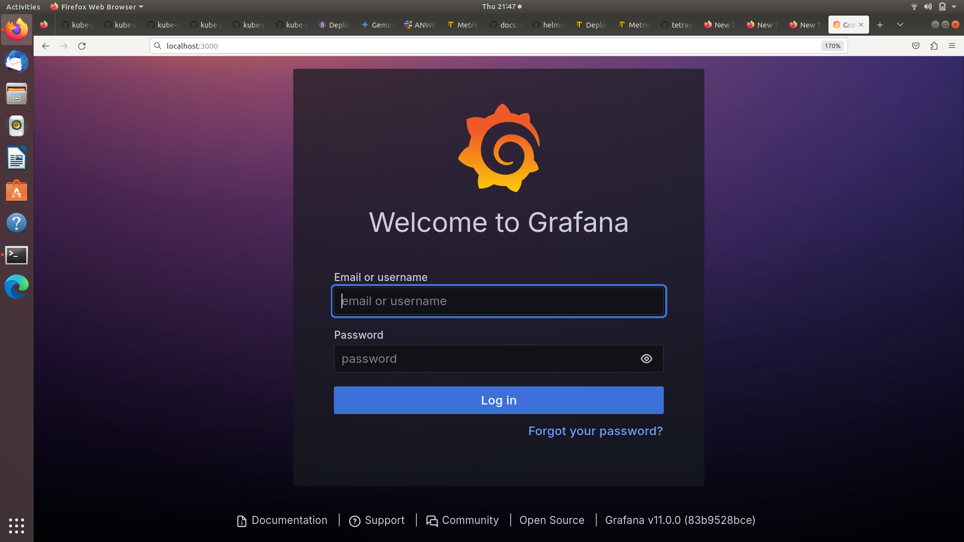

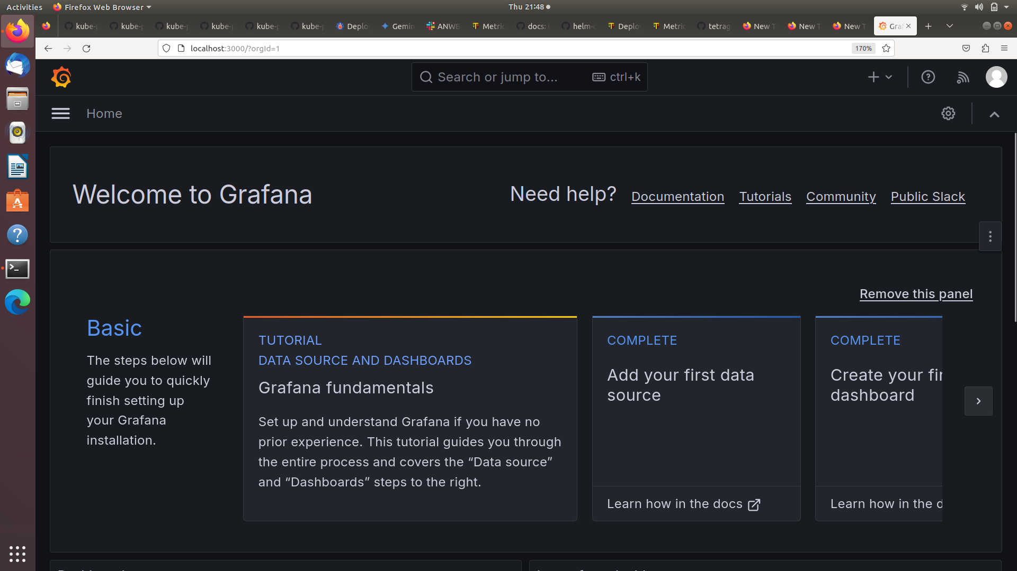

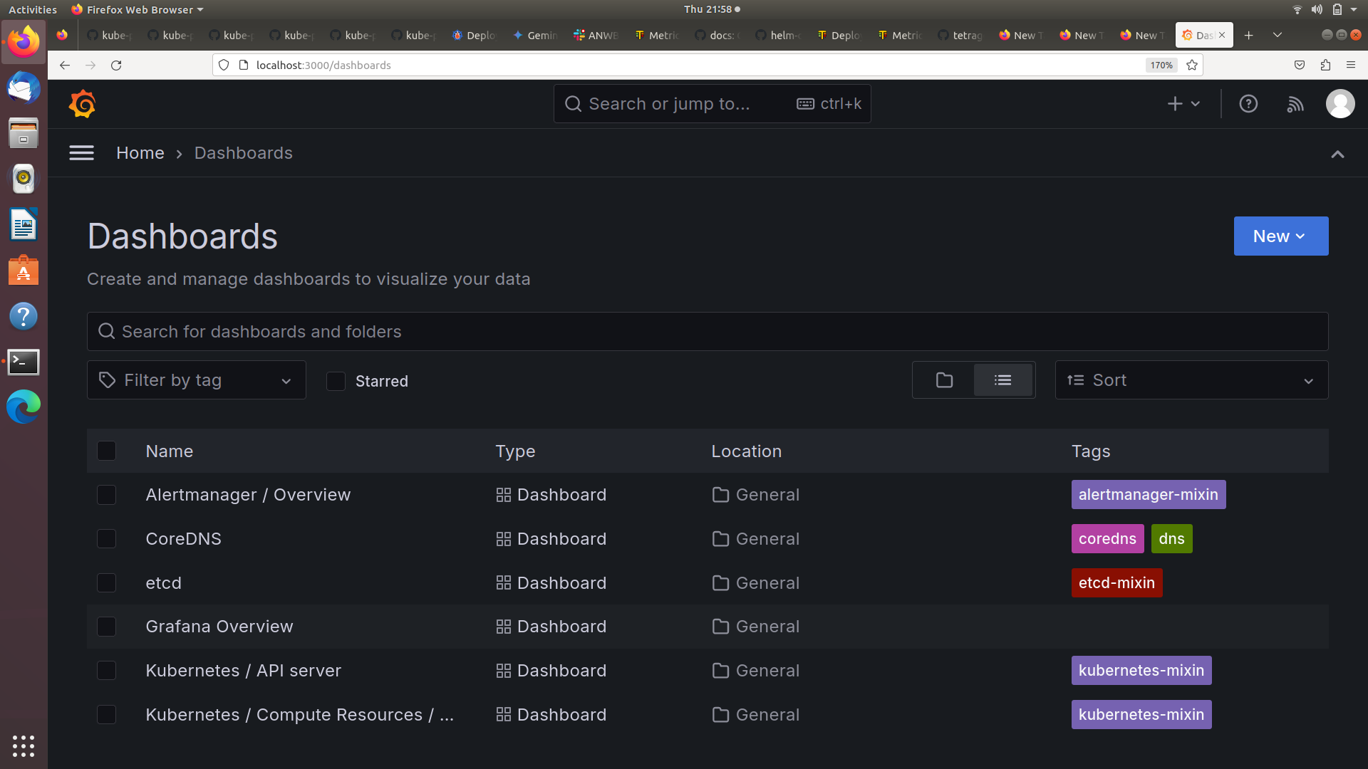Example: Grafana Dashboard

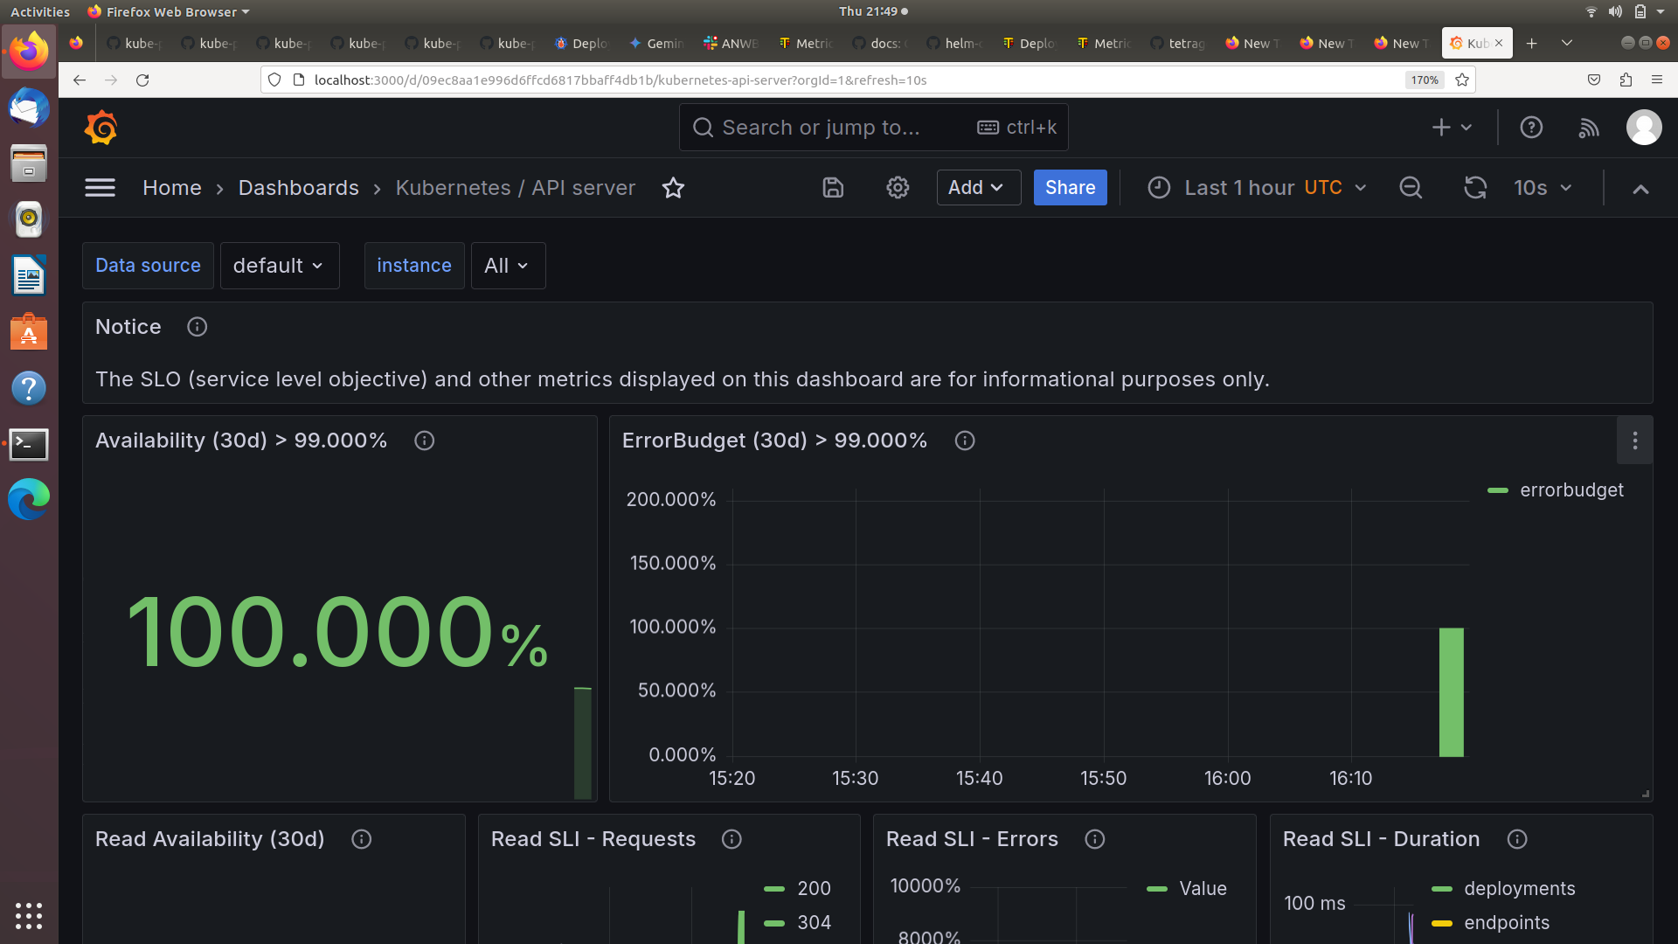

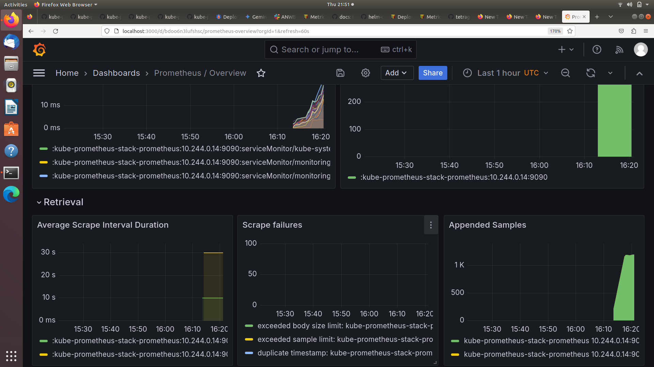

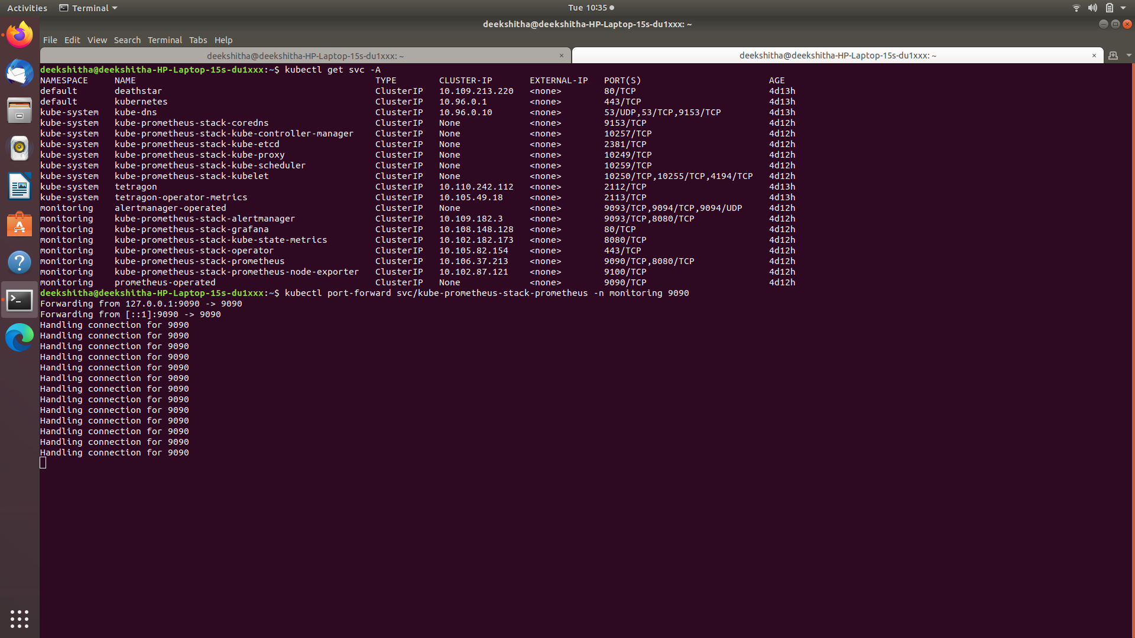

Prometheus User Interface: check whether tetragon metrics are healthy or not

